Amana Shari’ah-compliant Token

A Shari’ah-compliant framework for Islamic convertibility and tokenization of digital crypto assets

Whitepaper v1

January 7th 2022

Amana Protocol

www.amanaprotocol.io

Dr. Samir Mirali, PhD

# Abstract

Cryptocurrencies are becoming increasingly popular as both a store of value and transactional currency. As platforms continue to open up channels for the acceptance and utilization of cryptocurrencies in everyday transactions, the digital asset class is becoming progressively more popular. Unfortunately, for many of the adherents of the religion of Islam, cryptocurrencies continue to be deemed impermissible by Islamic scholars. The Islamic code of law that governs financial transactions, Shari’ah law, dictates that the high volatility in cryptocurrencies creates an inherent level of risk which invalidates cryptocurrencies as permissible investments for followers of the Islamic faith.

For the 1.5 billion followers of the Islamic religion, many Muslims also continue to face socioeconomic and geopolitical tensions which have created instability and unpredictability for their native fiat currency. Many Muslim families have seen the value of their assets decline rapidly as a result of crashes in currency and runaway inflation. Rapid declines in purchasing power have placed tremendous pressure on struggling families who continue to battle against rising inflation, limited monetary liquidity and higher costs of basic goods. For other Muslims, they continue to live in countries whereby trade restrictions and limitations on international trade and employment have created socioeconomic pressure and an inability to participate or benefit from opportunities in international business or foreign trade.

The Amana Protocol has worked extensively with experts in the field of Islamic Finance, Islamic legal scholars and crypto technology specialists to develop a methodology that enables Muslims to purchase, hold, trade and redeem cryptocurrencies in a fully Shari’ah compliant framework. The Amana Protocol currently remains the only protocol to obtain a fatwa (Islamic legal declaration) for Shari’ah compliance from leading Islamic scholars. The full advantages of cryptocurrencies as a store of value, a means of transaction and as a secure and transparent network can now be accessed in a Shari’ah-compliant token by Muslims around the world.

# Methodology

With the rise in popularity and acceptance of the Solana Blockchain, the architecture of their Solana Program Library token (“SPL token”) has quickly become one of the most pre-eminent tools for the development of crypto tokens. The Amana Protocol has developed a fully Shari’ah-compliant SPL token on the Solana Blockchain in the form of an Amana token. These Amana tokens offer full transparency of the Blockchain and can dynamically track the pricing of the underlying cryptocurrency – Bitcoin or Ethereum. Amana token holders will benefit from the underlying cryptocurrency’s efficiency in transaction volume, distribution and execution of smart contracts.

By creating a Shari’ah-compliant layer of market microstructure and using smart contracts to manage the distribution, pricing and supply of Amana tokens, the Amana Protocol creates a layer of infrastructure to provide stability and oversight in an otherwise non-Shari’ah compliant market. By pegging the token price to the underlying Bitcoin or Ethereum and regulating the supply of tokens, Amana tokens are designed to function as stablecoin while also retaining many of the benefits of the underlying cryptocurrencies.

The permissibility of the Amana protocol as a Shari’ah-compliant methodology of “Islamization” of tokens is backed by a fatwa published by a leading group of Shari’ah scholars who will remain as part of the governance structure of the Amana Protocol.

# Shari’ah Compliance

Shari’ah Compliance is obtained and regulated by a systematic framework that is fully integrated in the Amana Protocol. The Governance Committee is put in place to ensure that the Shari’ah Scholars, Auditing entity and Blockchain function in a clear unified framework to support the continued compliance and permissibility of the Amana Protocol.

The Shari’ah Supervisory Board of licensed and regulated Islamic Asset Manager, Algebra Commodities, headquartered in Kuala Lumpur, Malaysia has issued a fatwa certification on the Islamic compliance of the Amana Protocol and the Amana Protocol Pricing Algorithm engine. This certification extends to the permissibility of the Amana protocol as a Shari’ah-compliant methodology of “Islamization” of tokens. Algebra Commodities will remain involved in providing Shari’ah support, governance and oversight for the Amana Protocol and its activities.

The Governance Committee is fully integrated into the governance and management of the Amana Protocol, and as such functions as an additional layer of security and monitoring.

Such compliance is necessary on an ongoing basis to not only ensure adherence to the Shari’ah requirements of the protocol but also to provide additional oversight and transparency into the activities of the custodian, the distribution of the tokens and the transactions in the Blockchain.

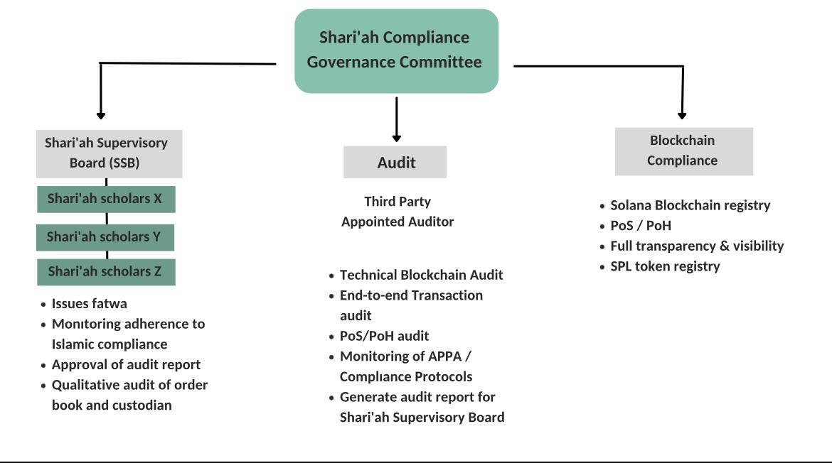

# Pricing

The Amana tokens have been designed to directly track the underlying price of the asset with pricing at 1:1 parity. The Amana Bitcoin (ABTC) will track 1:1 with Bitcoin at the prevailing market price, similarly the Amana Ethereum coin (AETH) will track 1:1 with Ethereum at the prevailing market price. Amana token holders can then buy, hold, exchange and sell the Amana coins in an end-to-end Shari’ah-compliant transaction with full pricing visibility of the underlying Bitcoin or Ethereum. Bitcoin can also be converted into ABTC and Ethereum can be converted into AETH via the Amana Protocol Pricing Algorithm (the “APPA”) enabling holders to convert their current non Shari’ah-compliant holdings into Shari’ah-compliant holdings while retaining the benefits and value of their holdings.

The Amana Protocol Pricing Algorithm is a proprietary technology engine which serves as the execution backbone of the Amana Protocol. The APPA is endowed with several capabilities including (i) Dynamic Load Management, (ii) Market Making, (iii) Pricing Engine, (iv) Stabilization Machine - Artificial Intelligence, (v) Liquidity Model and a (vi) Tracking Algorithm.

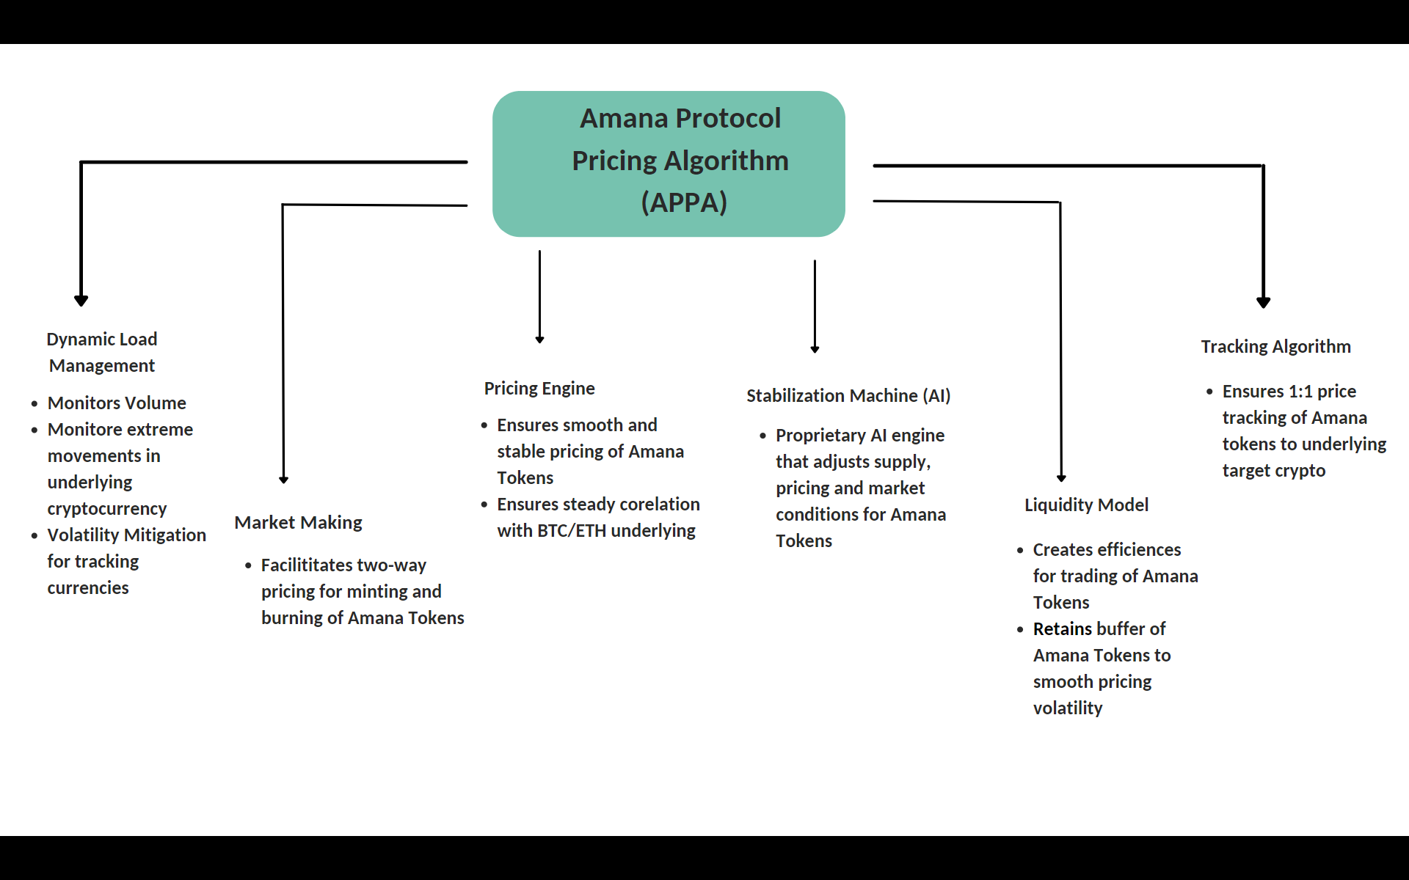

Functionally, the APPA enables the Amana tokens to operate largely as stablecoins with a comprehensive back-end architecture to ensure formulaic and dynamic pricing. The APPA’s ability to tap directly into the market pricing of cryptocurrencies is designed to further eliminate the excessive volatility and pricing risk of the underlying cryptocurrencies they are tracking.

Given this layer of pricing stability, Holders can then purchase ABTC and AETH directly to benefit from exposure to BTC and ETH without the daily volatile price and market movement fluctuations. All transactions will be fully regulated and managed by the Amana protocol infrastructure using the APPA engine, the Shari’ah compliance governance model and their dynamic market microstructure model. The Amana Protocol will first focus on major currencies for the Amana Protocol such as Bitcoin and Ethereum but may extend to include other major cryptocurrencies.

# Market Microstructure

* **Algorithmic** - This is a mechanism followed by some tokens on the Solana Blockchain whereby demand and supply are controlled by smart contracts in order to keep the price of the token in line with a target fiat currency. Some examples of this are Dai, NuBits and Carbon.
* **Blockchain** - Assets are stored within the Solana Blockchain which utilizes Proof of Stake and Proof of History to document all transactions. This repository of reserves is utilized in various forms by Tether, True USD, Globcoin, USDC (USD), Digix (gold) and AAA reserve (governmental bonds)
* **Governance** - The Amana Protocol itself is monitored by a third party auditor who reports directly to the Governance Committee and is furthermore regulated by its Shari’ah Islamic scholars and Solana Blockchain.
* **Compliance** - The Amana Protocol is backed by a *fatwa* (Islamic legal approval). The Amana Protocol was approved by a consortium of Islamic scholars who preside over numerous boards, financial institutions and development initiatives across 23 countries given the Amana Protocol compliance across multiple Islamic countries and jurisdictions. This is the only fatwa obtained for a Shari’ah compliant tokenization platform.
* **Market Making** – The Amana Protocol has built a trading infrastructure to provide two-way liquidity and pricing stability to the market for holders of Amana coins. This layer of market making enables the Amana coins to benefit from smooth pricing, full transparency and efficient execution in a regulated and secure market environment.
* **Verification & Management** - Amana tokens holders benefit from transparency and security by tapping into the architecture of the Solana Blockchain. Instead of relying entirely on one institution, they rely on a consortium of institutions performing different roles within the Solana network. This verification process is performed on a Proof of Stake consensus (PoS) in addition to Proof of History (PoH) which are attributes of the Solana blockchain. Unlike centralized solutions (USD), ABTC and AETH will be fully accounted for with transactions posted on the Solana Blockchain as per PoH and PoS protocols. There is no additional secondary utility/payment token required to use ABTC or AETH.

# Use Cases

## Tokenization Benefits

The act of tokenizing assets can:

* Increase speed of transactions

Solana blocks can be created every ~400 milliseconds (compared to 15 seconds on Ethereum’s network) and it is possible for Solana to handle up to 65,000 transactions per second (TPS). This speed is considerably faster than transacting natively compared to many other assets including Bitcoin, Ethereum, gold, and fiat currencies

* Cost of Transactions

The Solana network requires less time to generate new blocks on the Blockchain and the network can handle up to 65,000 TPS, resulting in costs that are considerably less than other cryptocurrency networks.

* Reduce the number of intermediaries

One of the key benefits of assets on a blockchain is their ability to be transacted without intermediaries. Every token holder retains control and discretion over their own tokens.

* Enhance security

Tokenization enables users to have full control of private keys of the asset. Users who do not want to hold keys can reduce counterparty risk by moving it from exchanges to a security-focused custodian.

* Usability

The SPL Token standard is being adopted by a large number of institutions and products. This provides users with a variety of exchanges, wallets, and Dapps to use while handling their tokenized asset. They also have the ability to move tokens quickly in an accessible and open-hour trading market.

* Transparency

The total number of tokens, token creation transactions, token removal transactions, number of token holders, and rules for transfers can be seen on a public block explorer by anyone. This level of transparency is not usually available for assets like fiat currencies, commodities, and stock and is an attribute of Decentralized Finance.

# Additional Benefits of Amana Protocol

## Benefits of Stable Cryptocurrency

Tokens backed by fiat currencies or cryptocurrency majors offer a safer way for traders to keep their money in a cryptocurrency without having to worry so much about price fluctuations or volatility. Stablecoins also give holders access to a mechanism that may offer more stability and transferability as a means of transaction than their native fiat currency. This is particularly useful for traders on both centralized and decentralized exchanges and holders seeking a store of value where there is no direct way of transferring fiat currency. Platforms that enable holders to transact with the stable tokens such as ecommerce, third party retailers, marketplaces and financial technology intermediaries create further support for such stablecoins.

## Interoperability between cryptocurrencies

As we see an expansion in the number of cryptocurrencies today, each one focuses on some aspect of digital value exchange. Some such aspects are transactional throughput, privacy, cheap transaction fees, smart contract ability, and decentralization. The Amana Protocol would make it easy to represent the value of any other cryptocurrency, such as Bitcoin, Ethereum, Avalanche on Solana and thereby enhance it with many of the capabilities of the Solana blockchain.

## Solana Blockchain

The Solana Blockchain holds numerous benefits, namely:

1. Speed of Transactions

In Transactions per Second (TPS), Solana needs only 400 milliseconds to mine a block and can handle up to 65,000 TPS.

1. Costs per Transaction

The fees in each crypto transaction varies from Blockchain to Blockchain, but Solana is vastly cheaper than Ethereum at an average cost per transaction of $0.00025.

1. Less Latency

Typically with processed transactions there is a waiting period referred to as a Mempool or Latency between the time it takes to process the transaction and register that transaction on the Blockchain. Solana does not have a Mempool and processes the transaction nearly instantaneously.

1. More Bandwidth

Sharing data within the network can cause bandwidth problems which can slow down the Blockchain. Solana developed a protocol called Turbine which breaks each block down into different packets which can then be transmitted and/or retransmitted, essentially distributing the load across various groups of computers to decrease bandwidth constraints and create a more resilient network.

1. Environmentally Friendly

Several cryptocurrencies use Proof of Work (PoW) which utilizes considerable computing power resulting in high electricity usage. Solana uses Proof of Stake (PoS) and Proof of History (PoH) algorithms which are energy efficient as they use far less computing power for processing.

## Shari’ah Compliance

Shari’ah-compliant Tokenization provides an additional way to enforce governance and compliance. Such policy enforcement makes rules more transparent and doesn’t rely on one single party to enforce them. Based on the type of asset, there could be a need to enforce rules on asset transfer or trade to ensure compliance and participation in accordance with the directives of the Governance Committee.

# Considerations

## Pricing

Given that Amana tokens are required to track prices of freely traded cryptocurrencies, extensive work has been conducted to ensure that the Amana Protocol protects against slippage, higher transaction fees and execution latency. Current low transaction costs of the Solana Blockchain and the platform’s processing efficiency support ideal pricing conditions.

## Tracking

Cryptocurrency tracking requires the Amana Protocol to have the capability to maintain two-way pricing and transact with the market seamlessly. The Amana Protocol market microstructure and market making engine ensures that the target cryptocurrencies of Bitcoin and Ethereum can be tracked.

## Trust

Asset tracking tokens require trust in the institution(s) managing and monitoring the asset. The Amana Protocol uses a governance structure including third party auditors, Islamic legal scholars and the working functionality of a fully transparent Solana Blockchain to ensure that the holder, custodian and token operate in a fully open manner. The automation of all transactions and utilization of smart contracts protects the integrity of the Amana Protocol.

## Governance

When there are multiple stakeholders in the system, there is a governance challenge with how to handle changes made to the token. The Amana Protocol is engineered to ensure that there is complete adherence to the regulation, procedures and compliance in an integrated and transparent framework.

# Implementation and Technology

The Amana Protocol will access the cryptocurrency market to obtain pricing for the underlying currencies, then mint tokens for customers to be held by the custodian. The tokens are created against the current pricing of the underlying, tracked token using the market microstructure of the Amana Protocol. This is done through minting (creation of tokens) and pricing (pricing the token against Bitcoin/Ethereum). These transactions will be available publicly and can be viewed by anyone through a block explorer. After the initial exchange, the Amana Protocol will maintain a buffer of tokens so that they can exchange it with users and provide two-way liquidity.

# 

## Wallet setup

Customers are expected to have a wallet that will use multi-signature with all keys controlled by Amana Protocol; the custodian. The wallet will only be able to be sent to the whitelisted custodian address on Blockchain. All minting and pricing transactions are expected to be done in real time.

## Minting

Minting refers to the process of creating new Amana tokens. Minting is completed within the Amana Protocol, but needs to be “initiated” by a customer. It is a set of transactions done by the Amana Protocol which interacts with the market, the custodian and the customer.

## Burning

Burning refers to the process of redeeming or eliminating existing Amana tokens. Burning can take place when the customer seeks to liquidate their token in exchange for fiat currency. The process is completed within the Amana Protocol, but needs to be “initiated” by a customer. It is a set of transactions done by the Amana Protocol which interacts with the market, the custodian and the customer.

## Sequence to Mint New ABTC/AETH

* Customer initiates a transaction with Amana Protocol and authorizes the custodian to accept minting of X number of ABTC/X number of AETH
* Customer funds transaction with Custodian via wallet
* Amana Protocol accesses market and uses APPA pricing algorithm to price ABTH/AETH and creates wrapped Shari’ah-compliant token
* The Amana token contract is sent to the Custodian
* The Custodian holds the Amana token on behalf of the Customer and sends confirmation to the Customer
* SPL token Blockchain transaction record also sent to Customer

## Sequence to Redeem/Burn ABTC/AETH

* Customer initiates a transaction with Amana Protocol and authorizes the redemption/burning of X number of ABTC/X number of AETH
* Amana Protocol accesses market via APPA to redeem ABTC/AETH
* Proceeds of redemption sent to Customer’s account
* Confirmation of trade and transaction details sent to Custodian and Customer
* SPL token Blockchain transaction record also sent to Customer

# Fees

Transfers of ABTC/AETH between users will have no cost apart from network fees. There are three types of fees in the network:

* Custodian fees: This is taken by the custodian at the time when a merchant mints or redeems/burns Amana tokens.
* Protocol fees: This is taken by Amana Protocol to transact with the market and convert/price/structure the Shari’ah-compliant wrapped token
* Blockchain transaction fees: These are standard transaction fees to access and create on the Blockchain.

# Transparency

There will be full transparency in the functioning of the Amana token. All key details of the network will be reflected in a dashboard, some of which are:

* Names and details of institutions performing different roles in the network
* Status of mint and redemption/burn orders (pending, processing, cancelled, complete)
* Total amount of ABTC/AETH stored by custodians
* Total amount of ABTC/AETH in the network (Will be the same or slightly lower than ABTC/AETH stored)
* Quarterly audits in the form of transactions which prove that the custodian has the keys to the digital token assets
* Custodians Solana addresses
* The Bitcoin/Ethereum address associated with Amana Protocol, controlled by the custodian
* Links to the open source token contract code / deployed contract on a block explore

# Conclusion

The Amana Protocol functions as a Shari’ah-compliant layer of market microstructure to regulate the distribution, pricing and convertibility of Amana coins, and in doing provides stability and oversight in an otherwise non-Shari’ah compliant asset class.This Shari’ah-compliant framework for the Islam convertibility and tokenization of digital crypto assets enables Muslims around the world to now benefit from the flexibility, transparency and functionality of this digital asset class.